The Australian Baseball Alumni has been established with the fundamental purposes of promoting Australian baseball and providing a means for ongoing connection - and reconnection - between any and all persons who have had an involvement in the sport, at any level and in any capacity.

In an effort to support the baseball community the Alumni has coordinated several fundraising opportunities to support players representing their country. The Alumni has been fortunate enough to have some excellent items donated for fundraising purposes and are excited to extend the opportunity to state representative players to assist in fundraising for the 2016 National Championships.

Players will have the opportunity to sell raffle tickets and keep half of the proceeds of the money they raise. The other half of the proceeds will go back to the Alumni and be redirected into future baseball initiatives.

Raffle Details

Tickets are priced at- $2 each or 3 for $5
Raffle will be drawn at the National Championships in Sydney on 18th January 2016
The Australian Baseball Alumni will deliver all prizes to prizewinners shortly after the draw.
Please ensure name and mobile number is on each ticket sold.
Prizes;
- Authenticated signed Miguel Cabrera Baseball- kindly donated by the Detroit Tigers
- ABL Sam Bat signed by Grant Balfour- kindly donated by the Sydney Blue Sox
- Authenticated signed Derek Jeter baseball card- kindly donated by Dean Lawler
- Authenticated Pinnacle Joe DiMaggio baseball card set including a signed Joe DiMaggio card- kindly donated by Dean Lawler
- Trent Oeltjen Signed Sydney Blue Sox jersey- kindly donated by Trent Oeltjen
- Game used Athens Olympics baseball signed by major leaguer and gold medal game starter John Stephens- kindly donated by John Stephens

For further details and photographs of these prizes please head to abpaa.com

Prize details

Miguel Cabrera ball- this ball was donated by the Detroit Tigers. The ball has a MLB authentication hologram and is displayed in an acrylic case. Approx. worth $350
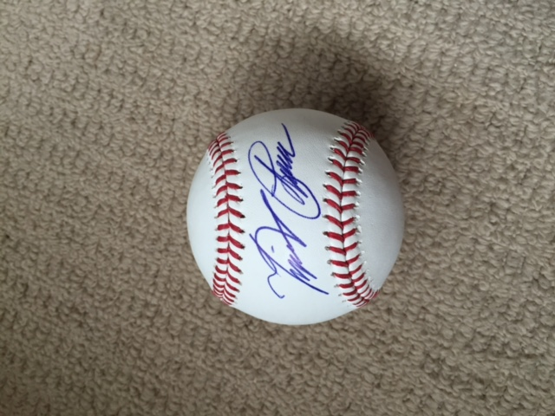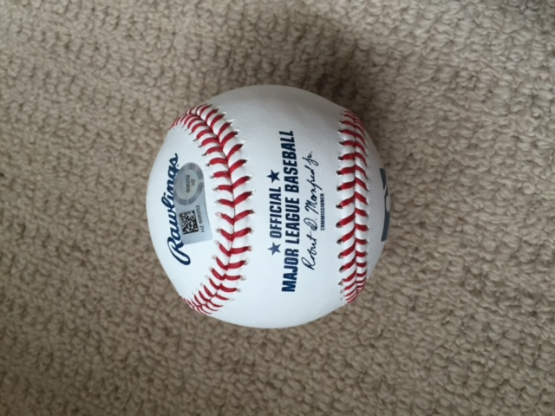

ABL bat signed by Grant Balfour- donated by CEO Mark Marino from the Sydney Blue Sox, this is a offical ABL Sam Bat that was signed by Grant Balfour. Approx. value $300

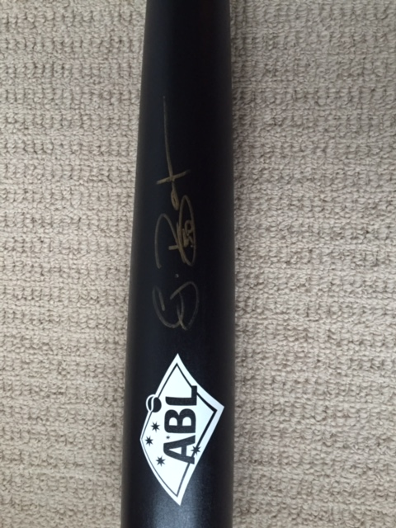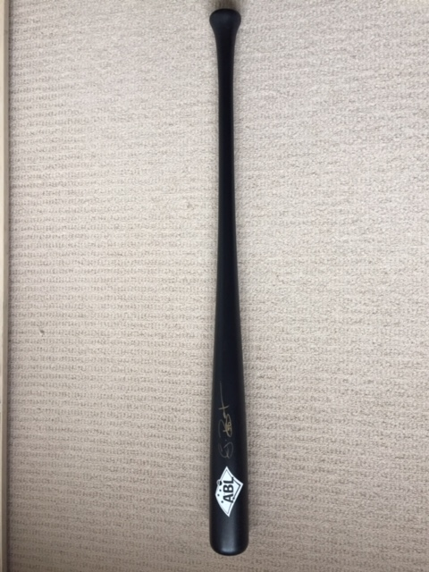
Derek Jeter signed card- donated by Dean Lawler from Sports and Spinal Physio in Port Macquarie, this card features Derek Jeter in High School. Card is signed and authenticated. Approx. worth $250
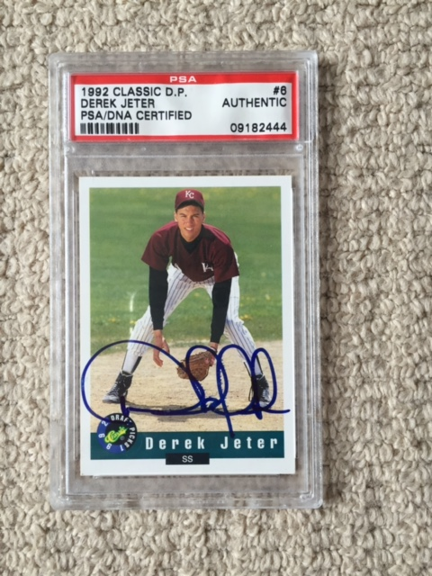

Joe DiMaggio Box Set- donated by Dean Lawler from Sports and Spinal Physio in Port Macquarie, this box set contains Joe DiMaggio baseball cards as well as an authenticated signed Joe DiMaggio photo. Approx. worth $250

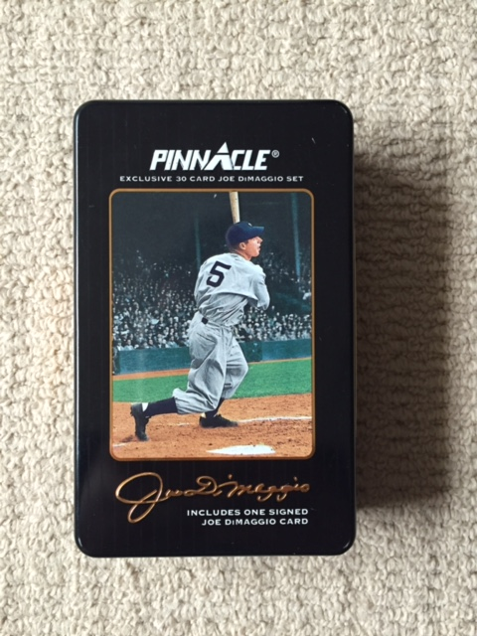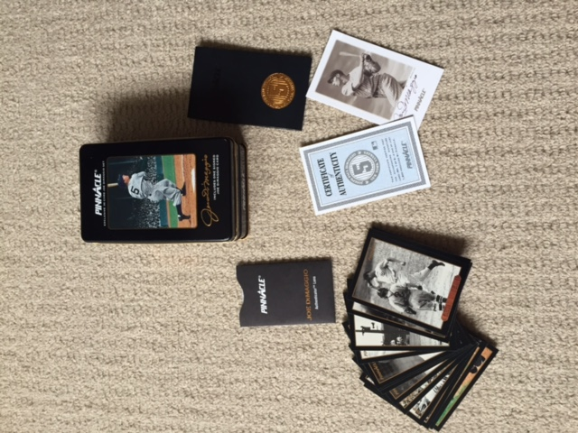

Trent Oeltjen Signed Jersey- Sydney Blue Sox signed jersey by former Major Leaguer Trent Oeltjen. Approx worth $200

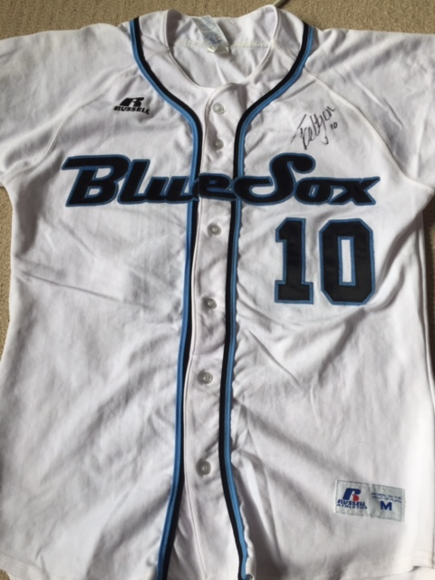

Game used Athens Olympics baseball signed by John Stephens- kindly donated by former Major Leaguer and Olympic silver medalist John Stephens, this Mizuno baseball is a game ball from the 2004 Athens Olympics. John has signed this baseball. Approx. value $200

